**Lionel Perret**

Route de Diesse 8

2518 Nods

Lionel.Perret.76@gmail.com

+41 76 2311093

*Data Science Project*

**Prediction of Avalanche Danger Levels with Meteorological Data**

Conceptual Design Report

*16 October 2020*

# Abstract

This data science project analyses the data set of 13’918 avalanches, recorded in the Davos area from 1998 to 2019 and combine it with the meteorological data of the Weissfluhjoch station, above Davos. The avalanche data set includes information on the size, the type, and the number of avalanches. For each day, when avalanches are recorded, the official avalanche danger level is also present in this database.

From the snowfall quantity, the wind and the temperature data from the weather dataset, a binary variable describing the *Critical Fresh Snow* limit is created, to investigate if more avalanches were recorded with those conditions. The results showed that this variable gives an indication that the number of avalanches per day increased but also that other LOCAL meteorological parameters play an important role as well.

The final objective of this project (module 3) is to predict the avalanche danger levels, with the meteorological parameter available in the Weissfluhjoch data set and to investigate the degree of accuracy of this prediction.

# Table of Contents

Abstract 0

Table of Contents 1

1. Project Objectives 2

Project - Module 1 - Objectives 2

Project - Module 2 – Objectives 3

Project – Module 3 – Objectives 3

2. Methods 4

Infrastructure 4

Tools 4

Python Libraries 4

3. Data 5

*Data Set 1* Snow avalanche data Davos, Switzerland, 1999-2019 5

*Data Set 2 Weissfluhjoch* Meteorological and snowpack measurement 1999-2017 7

4. Metadata 9

5. Data Quality 10

Meteorological measurements accuracy 10

Geographic position differences in avalanches and meteorological measurements 10

Manually recorded Variables in avalanche dataset 10

6. Data Flow 11

7. Data Model 12

Conceptual 12

Logical 12

Physical 12

8. Risks 13

Recording mistakes risk 13

Analysis mistakes risk 13

Data collection risk (Project Module 3) 13

9 Preliminary Studies – Module 2 14

10. Conclusion 18

Project Module 1 18

Project Module 2 18

Outlook Project Module 3 18

Broader outlook towards “LOCAL” Avalanche Danger Level Prediction 19

11. Acknowledgements 20

12. References 20

13. Table list 20

14. Figure list 20

# 1. Project Objectives

## Project - Module 1 - Objectives

The main activity for the project of this first module will be to get familiar with the 2 datasets used and then to achieve the following goals:

* Pre-process the avalanche dataset and start to describe statistically the avalanches that were recorded: Number of avalanches, types, sizes, causes, …
* Pre-process the meteorological dataset and create a binary variable *Critical Fresh Snow* condition for each day, using the definition of the Institute for Snow and Avalanche Research, Davos (SLF) about “Critical amount of new snow reached”**[1]**:

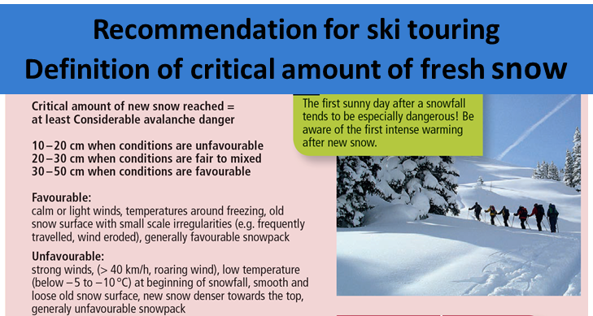

FIGURE 1.: Criteria That Defines Critical Fresh Snow Conditions

***Critical Fresh Snow* = 1** 🡺 **The meteorological conditions defined above are present** on that day

***Critical Fresh Snow* = 0**  🡺**The meteorological conditions defined above are not present**

***Note:***

*The above recommendation* “Critical amount of new snow reached = at least **Considerable** avalanche danger”refers to the European avalanche danger level, more information on its definition is given in table 1. below:

TABLE 1. : Avalanche Danger Scale, European Avalanche Danger Levels [2]

|  |  |  |
| --- | --- | --- |
| **Level** | **Characteristics** |  |
| **5**  **Very high** | **Extraordinary avalanche situation**  Numerous very large and extremely large natural avalanches can be expected. These can reach roads and settlements in the valley. |
| **4**  **High** | **Very critical avalanche situation**  Natural and often very large avalanches are likely. Avalanches can easily be triggered on many steep slopes. Remote triggering is typical. Whumpf sounds and shooting cracks occur frequently. |
| **3**  **Considerable** | **Critical avalanche situation**  Whumpf sounds and shooting cracks are typical. Avalanches can easily be triggered, particularly on steep slopes with the aspect and elevation indicated in the avalanche bulletin. Natural avalanches and remote triggering can occur. |
| **2**  **Moderate** | **Mostly favorable avalanche situation**  Warning signs can occur in isolated cases. Avalanches can be triggered in particular on very steep slopes with the aspect and elevation indicated in the avalanche bulletin. Relatively large natural avalanches are not to be expected. |
| **1**  **low** | **Generally, favorable avalanche situation**  No warning signs present. Avalanches can only be triggered in isolated cases, in particular on extremely steep slopes. |

## Project - Module 2 – Objectives

Following the pre-processing, those two datasets will be combined and the goals for the module 2 project are:

* Analysis of number of avalanches per day with regards to avalanche danger levels.

Here the aim is to investigate if the number of avalanches per day are increasing with the avalanche danger levels

* Investigate the influence of snow fall and other meteorological parameters on the number of avalanches per day. The binary variable *Critical Fresh Snow* created in module 1 will be used to split the data in 2 classes and the obtained distributions will be compared:

Distribution 1: Number of avalanches per day for the day where *Critical Fresh Snow* = 1

Distribution 2: Number of avalanches per day for the day where *Critical Fresh Snow* = 0

* Check the possibility to use the combined dataset for prediction of the avalanche danger levels with meteorological parameters

## Project – Module 3 – Objectives

The final goal of this project is to use and interpret the recorded meteorological data in the Weissfluhjoch defined area to predict the avalanche danger levels within this area.

To do that the model will be trained in using the two combined datasets used in module 1-2 and the model will be used to predict the upcoming avalanche danger levels in the Davos Area of the winter 2020-2021.

# 2. Methods

## Infrastructure

* Microsoft Surface Book 2 with Intel Core i5-8350U, 8Go, 256Go, SSD
* Windows 10 Professional, Version 10.0.19041

## Tools

* Jupyter Notebook (Version 6.0.0): Interactive computing product based on the platform Anaconda 2019.07 (Python 3.7 Version [6]). Data analysis is performed in Python 3

## Python Libraries

* *pandas*: Library and tool for dealing with data structures, data tables, manipulating data.
* *numpy*: Library and tool for calculating with data and arrays.
* *matplotlib*: Library and tool for the visualization of data in diagrams.
* *scipy*: Library and tool for mathematical calculations (scipy.stats: probability distributions, normality tests, regression etc.)

# 3. Data

## *Data Set 1* Snow avalanche data Davos, Switzerland, 1999-2019

*Description*: This dataset includes observations about all avalanches recorded in the region of Davos, Switzerland, during the winters 1998-1999 to 2018-2019 - 21 years – total 13’918 avalanches

**[3]**

*Variables* Date, avalanche number, snow type, trigger type, maximum elevation, minimum elevation, length, width, perimeter, area, avalanche size class, avalanche activity index, avalanche danger level

*Snow Type* variable:

* “dry” avalanche: Type of avalanche where the snow has not melted. This type of avalanche is either with fresh powder snow or “slab” snow. “Slabs” are caused by the effect of the wind on the snow.
* “wet” avalanche: In this avalanche, the snow as melt because of the sun and/or temperature. This type of avalanche is more frequent in the second part of the winter.

*Trigger Type* variable

* “EXPLOSIVE”: avalanche triggered artificially, for security reasons
* “NATURAL”: avalanche triggered by natural causes
* “HUMAN”: avalanche triggered by a person unintentionally
* “UNKNOW”: Triggered cause of the avalanche is unknown

TABLE 2.: Data from the Original Avalanche Dataset

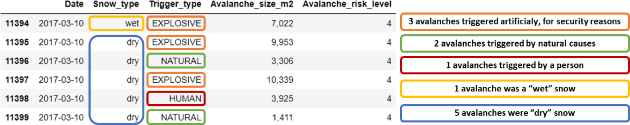 

TABLE 2. gives an example of the original data. There is one line per recorded avalanche, so several avalanches recorded on the same day are represented with different rows.

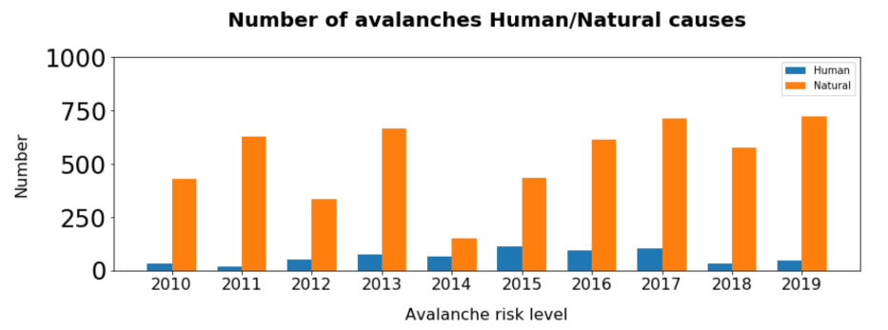

Over the years, the number of Natural triggered avalanches are fluctuating and in the past 2 years, the number of “HUMAN” caused avalanches is decreasing.

FIGURE 2.: Number of avalanches with Human/Natural Causes

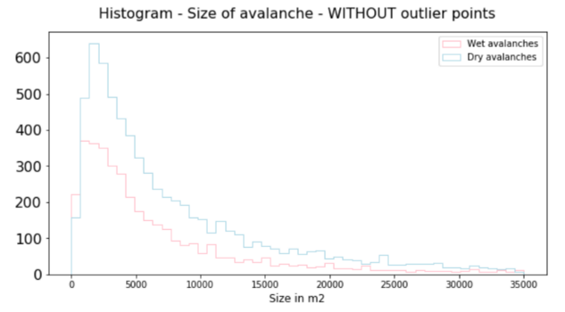

In FIGURE 3. the distribution of the avalanche size has a similar shape for “wet” and “dry” avalanches and is not normal.

FIGURE 4. shows the box plot of the 2 distributions with and without outliers. The avalanche size can be very big, in 2 cases for “dry” avalanches, above 1’000’000 square meters.

FIGURE 3.: Histogram Avalanche Size

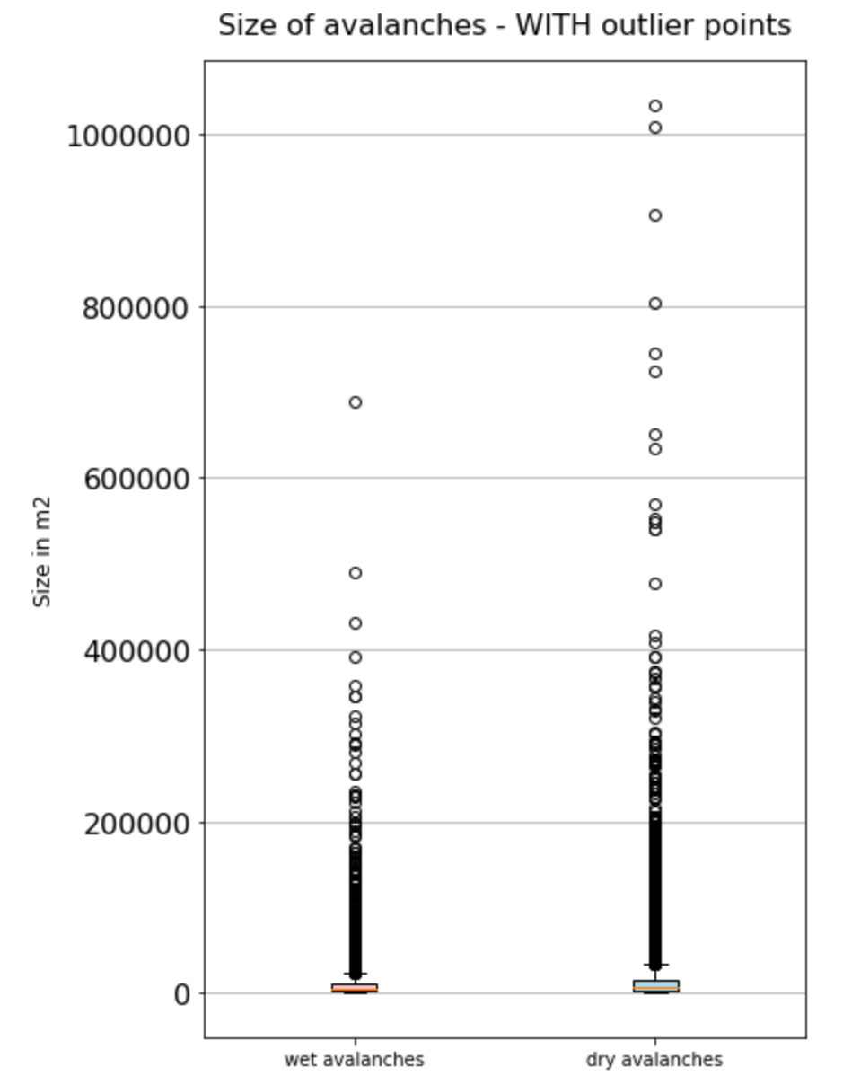 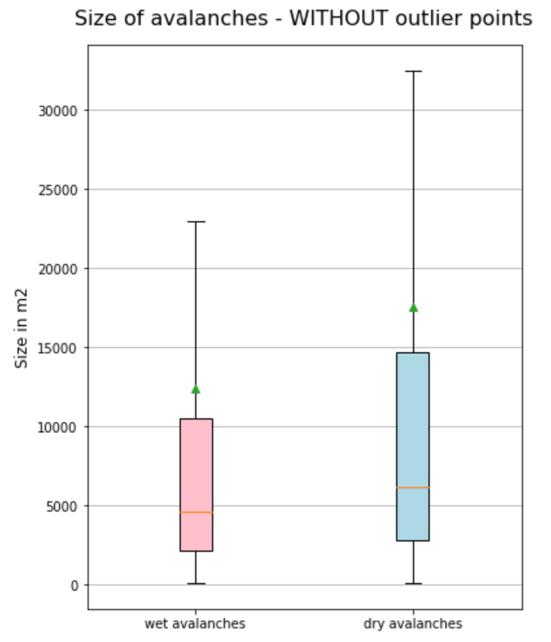

FIGURE 4.: Box Plot Avalanche Size

TABLE 3. below shows the statistic of “dry Avalanches.

TABLE 3.: Descriptive Statistic “dry” Avalanche Size

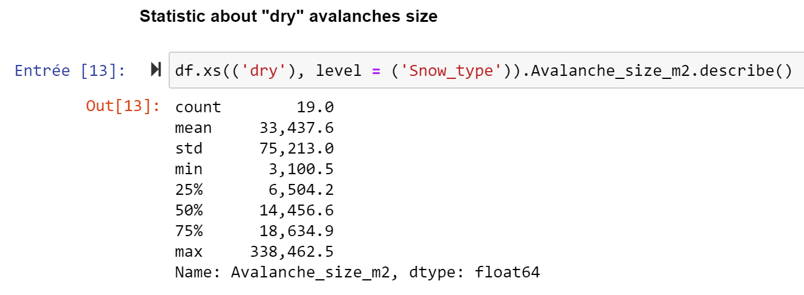

## *Data Set 2 Weissfluhjoch* Meteorological and snowpack measurement 1999-2017

*Description:* This dataset includes standard meteorological and snowpack measurements from the automatic weather station at Weissfluhjoch, Davos, Switzerland **[4]**

*Variables* Timestamp, air temperature, relative humidity, wind speed, wind direction, incoming short wave radiation, short wave radiation, incoming long wave radiation, outgoing long wave radiation, undercatch corrected precipitation, manually observed snow depth, once per day, automatic measured snow depth, ground temperature, surface temperature, snow lysimeter, measured snowpack runoff, snow water equivalent

TABLE 3. gives an overview of the raw data of 04.03.2017 and 05.03.2017. The meteorological parameters are measured every 30 minutes and *Snow_height* is manually measured every day between 06h and 09h:

TABLE 4.: Raw Data from the Meteorological data set

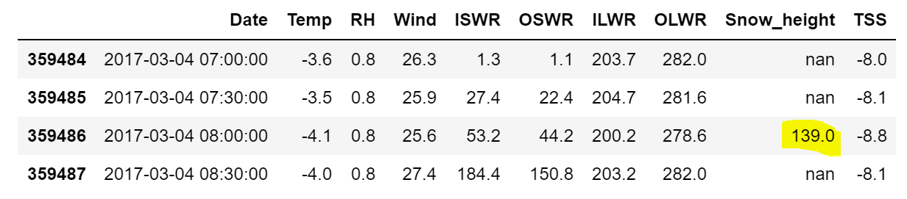 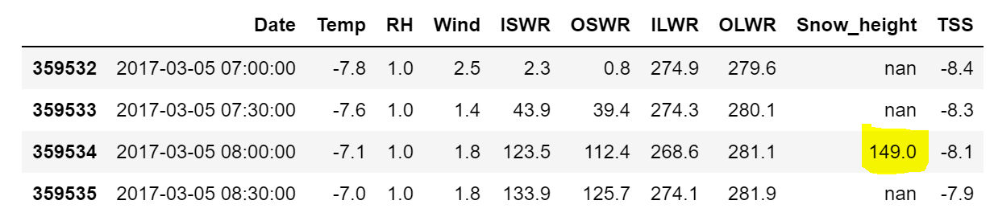

**Binary variable *Critical Fresh Snow:***

The *Critical Fresh Snow* variable was created using simplified criteria defined in FIGURE 5 below.

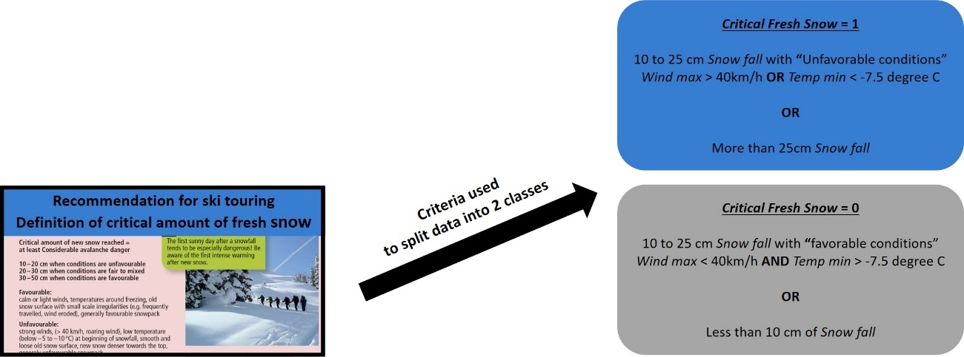

FIGURE 5.: Simplified Criteria for the Critical Fresh Snow Variable

TABLE 4. gives an overview of the data after the pre-processing, with the *Critical Fresh Snow* variable calculated

The 10cm snow falls on 04.03.2017 is obtained with the difference of the two *Snow_height* values in yellow in TABLE 3. The processed data in TABLE 4. is exported as a .CSV file in the *Meteo.ipynb* Jupyter notebook. The *Data model* chapter below gives a description of the used file names.

*TABLE 5.: Processed Data from the Meteorological data set (Meteo.csv File)*

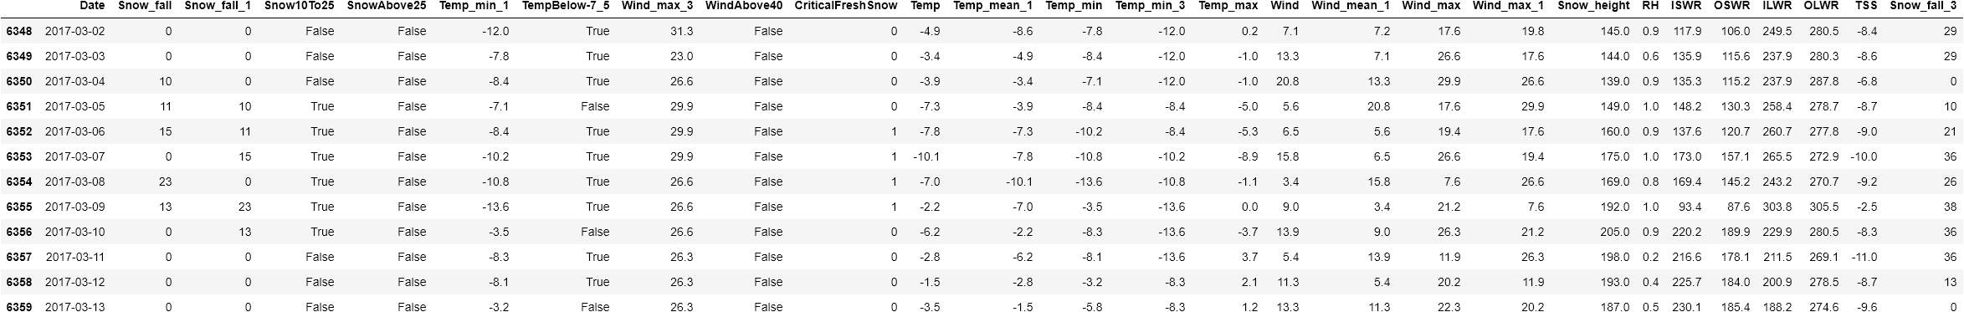

#### Descriptive statistic for the daily mean temperature is presented in FIGURE 6 below.

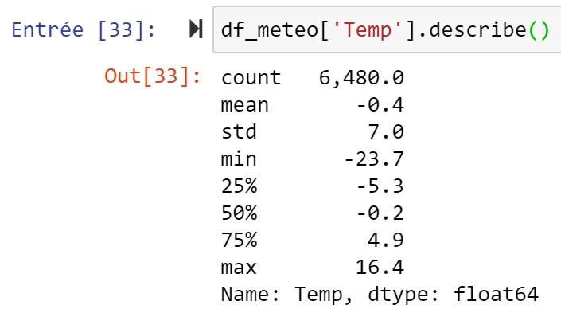 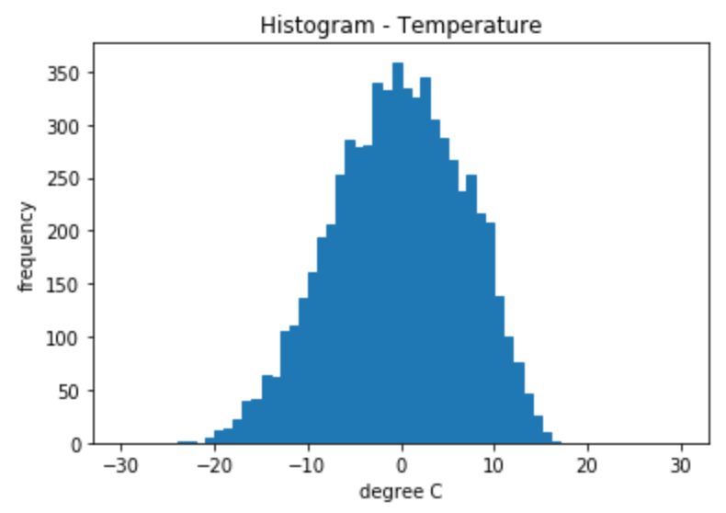

FIGURE 6.: Mean Daily Temperature - Weissfluhjoch Weather Station

#### Descriptive statistic for the sum of the snow fall of the last 3 days is presented in FIGURE 7 below.

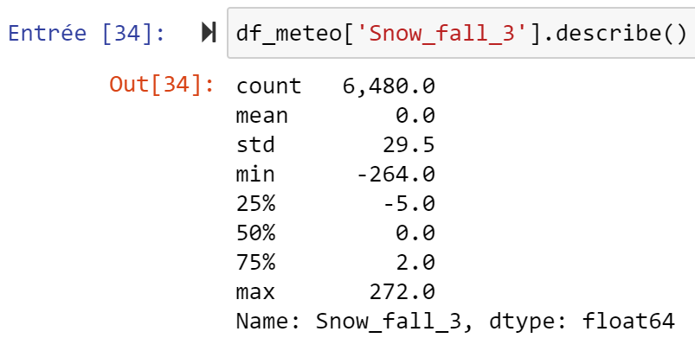 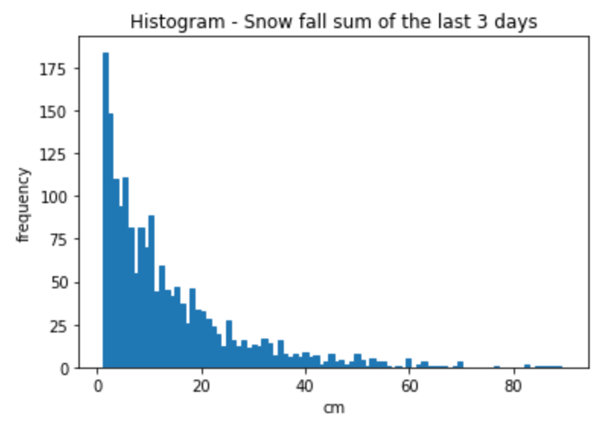

FIGURE 7.: Sum of snow fall of last 3 days - Weissfluhjoch Weather Station

#### Descriptive statistic for the mean daily wind speed value is presented in FIGURE 8 below.

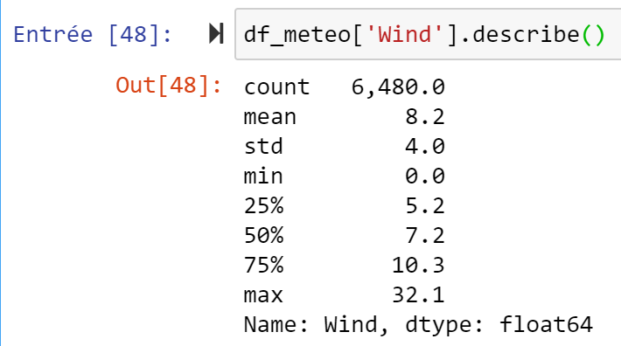 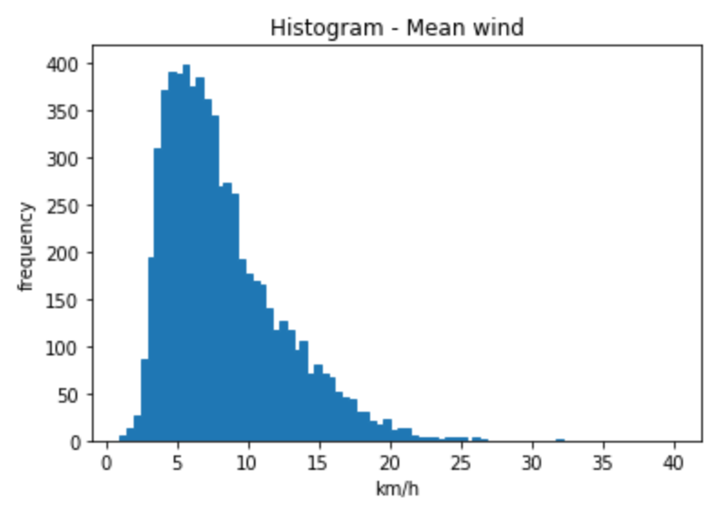

FIGURE 8.: Mean Daily Wind Speed - Weissfluhjoch Weather Station

# 4. Metadata

Metadata information can be found on the following Github directory:

<https://github.com/lionelperret76/M1-M2_Project/tree/main/MetaData>

In this directory:

* *Meteo_metadata.txt* contains the metadata information about the meteo variables that are found in the *Meteo.csv* file
* *Avalanches_metadata.txt* contains the metadata information about the avalanches variables that are found in the *Avalanches.csv* file

# 5. Data Quality

## Meteorological measurements accuracy

The meteorological measurements are mostly automatic. The precision of the temperature, wind, snow height measurement is not stated in the dataset information. The automatic measurement system at the Weissfluhjoch are expected to be precise enough for the analysis planned in this project.

## Geographic position differences in avalanches and meteorological measurements

The meteorological measurements available in the dataset are from only one location - The Weissfluhjoch is represented by the “blue dot” in FIGURE 6. below.

All the recorded avalanches are located within the red area, around Davos. As snow fall quantity, wind speed and temperature can be quite different at the avalanches location, some kilometer away and/or at another altitude than the measured meteorological values, this could have an impact on the analysis in this project.

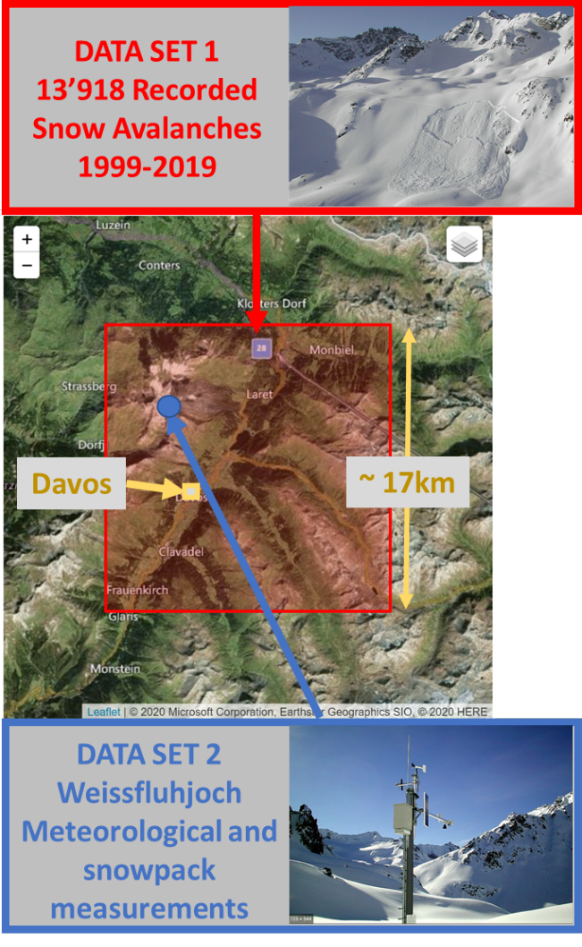

FIGURE 9.: Avalanche Recording Area and Weather Station Location

## Manually recorded Variables in avalanche dataset

The variables in the avalanche dataset are recorded manually. Recording mistakes are possible and could have an influence on the data quality and on the results of this analysis.

# 6. Data Flow

Figure 7. below represents the overall concept of this project and the data flow

pf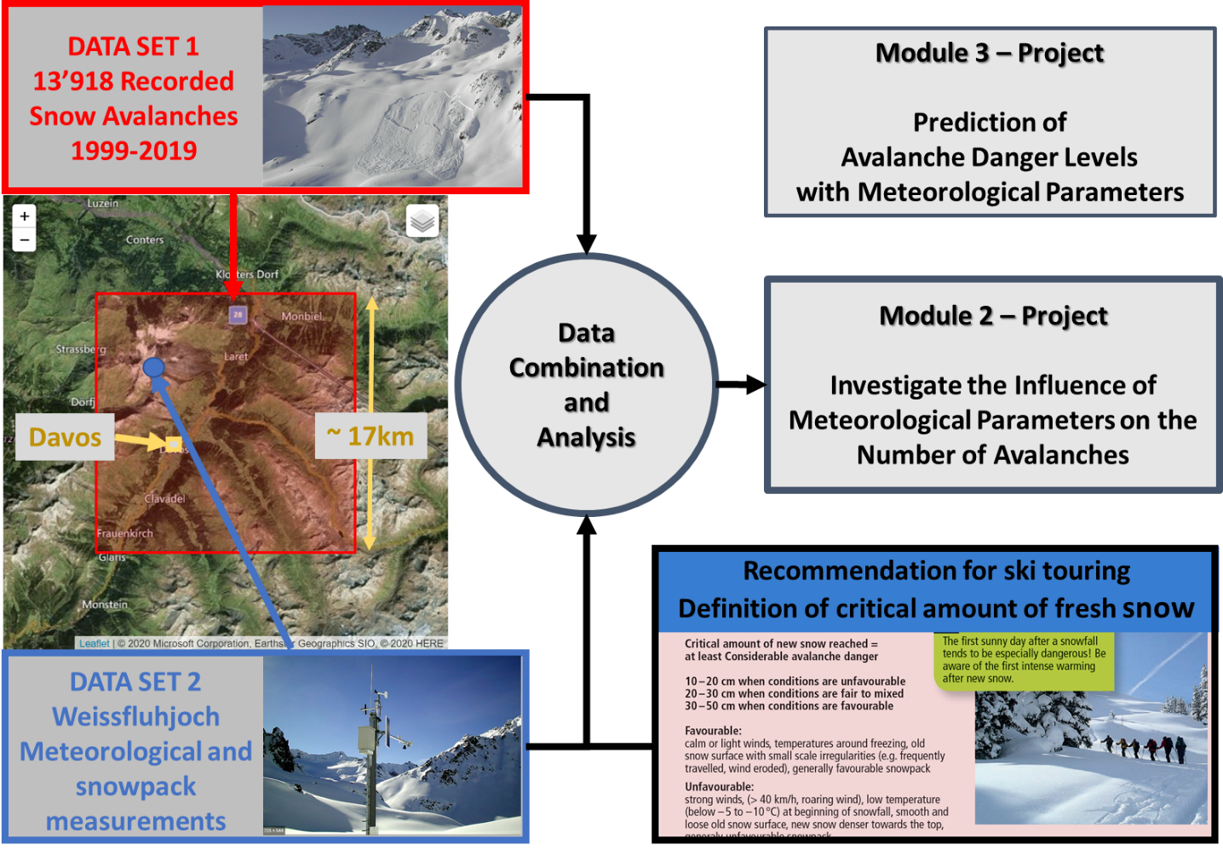

FIGURE 10. Data Flow / Project Concept Overview

The two datasets were downloaded from “EnviDat”, an environment data portal ([www.envidat.ch](http://www.envidat.ch)) on my laptop.

All the processing and analysis is done on my laptop and the outputs are:

1. The Conceptual Design Report document, with tables and figures

<https://github.com/lionelperret76/M1-M2_Project/blob/main/Lionel_Perret-CAS-ADS-M1_M2-Project_Report.pdf>

1. The Modul 2 project tables and figures available in the poster file

<https://github.com/lionelperret76/M1-M2_Project/blob/main/Lionel_Perret-CAS-ADS-M2-Poster.pdf>

All the other used files, datasets, and python Jupyter notebook scripts are available as well on github:

<https://github.com/lionelperret76/M1-M2_Project>

# 7. Data Model

## Conceptual

FIGURE 11.: Conceptual Data Model

## Logical

FIGURE 12.: Logical Data Model

## Physical

There is no need on external infrastructure and all this project will be done on my personal laptop/github.

# 8. Risks

## Recording mistakes risk

One of the risks is linked to the quality of the recorded data. Mistake could have been made in the recording of the avalanche variables (date, size, total number,) as already mentioned on the data quality chapter.

The avalanche and meteorological datasets are linked with the date parameter, so possible mistakes in the date of the occurred avalanches could have an influence on the quality of this analysis.

## Analysis mistakes risk

Another risk is data analysis mistake, as there could be bugs in my python code and in the use of the different available python functions and libraries.

## Data collection risk (Project Module 3)

The objective for the module 3 project is:

*“The final goal of this project is to use and interpret the recorded meteorological data in the Weissfluhjoch defined area to predict the avalanche danger levels within this area.*

*To do that the model will be trained in using the two combined datasets used in module 1-2 and the model will be used to predict the real avalanche danger levels occurring in the upcoming winter 2020-2021 in the Davos area.”*

This implies that Meteorological data from the winter 2020-2021 is collected. A solution for the automatic collection of those meteorological parameters needs to be found and there is a risk that the data cannot be collected as needed.

In case the collection of the data do not succeed, the backup plan is to split the available past data in a “train” and “test” sample, so that I can still investigate how accurate is the prediction.

# 9 Preliminary Studies – Module 2

* Module 2 Jupyter Notebook is available on github:

<https://github.com/lionelperret76/M1-M2_Project/tree/main/JupyterNotebooks/ProjectM2.ipynb>

This file was used to create the different figures-tables-illustration shown in my poster.

* A1 poster (pdf file) available on github:

<https://github.com/lionelperret76/M1-M2_Project/tree/main/Lionel_Perret-CAS-ADS-M2-Poster>

The different parts of this poster are also put as printscreen in the next pages

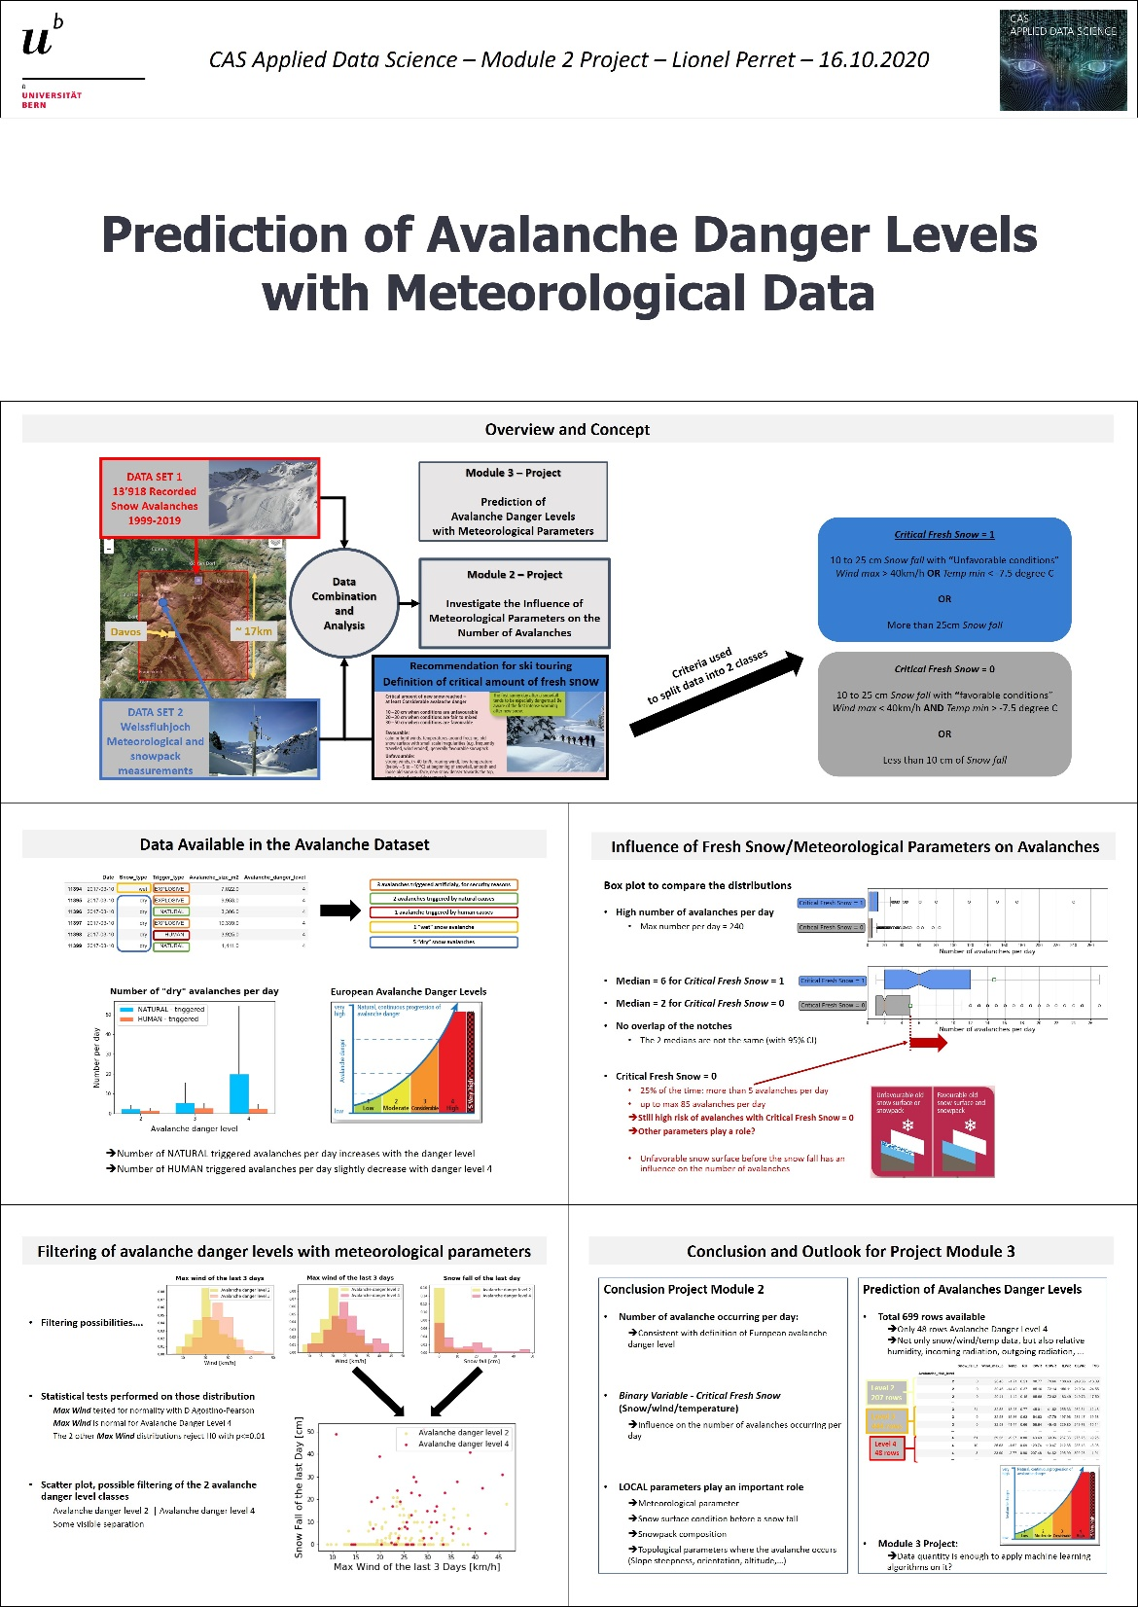

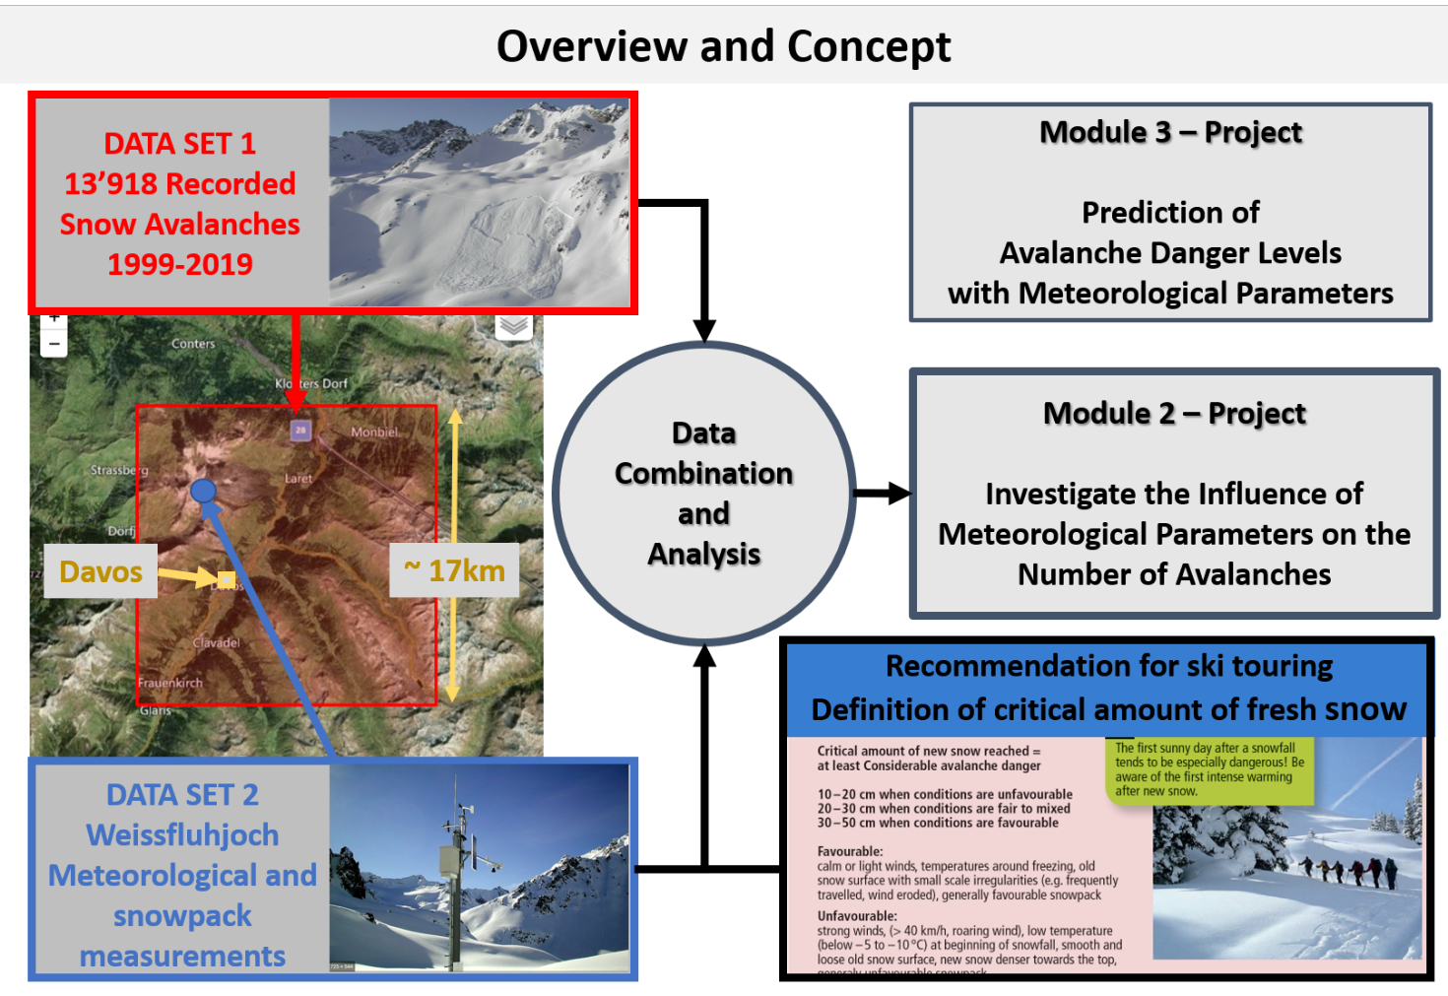

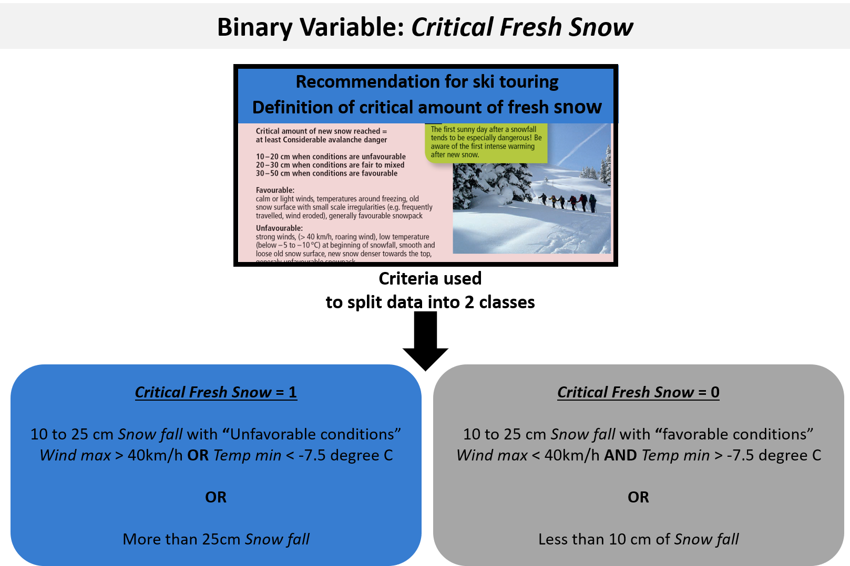

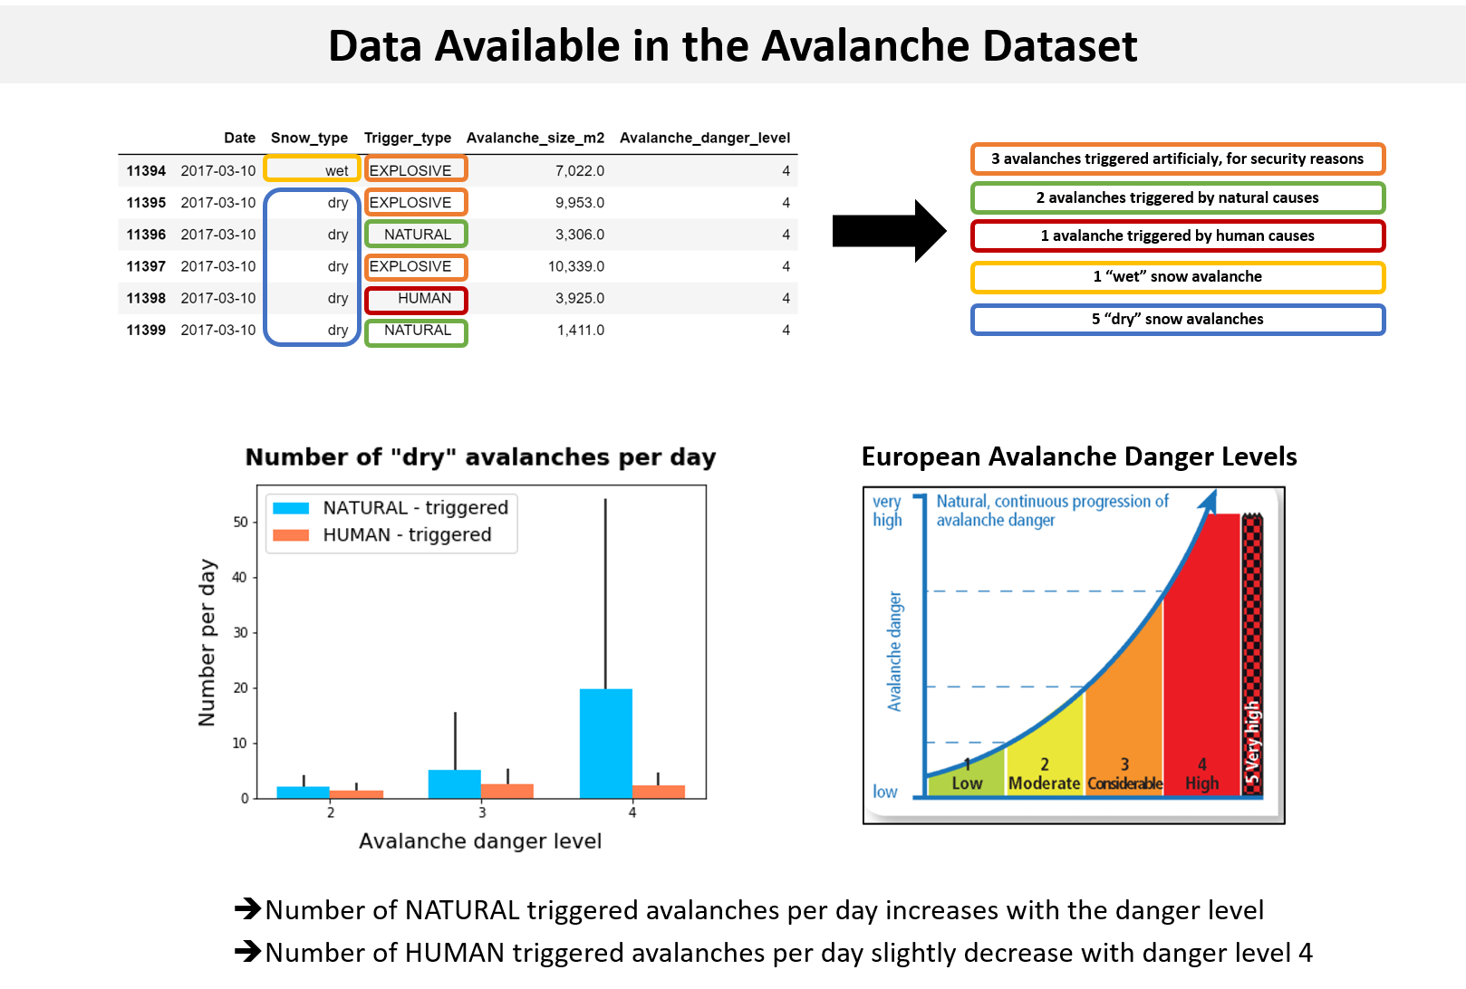

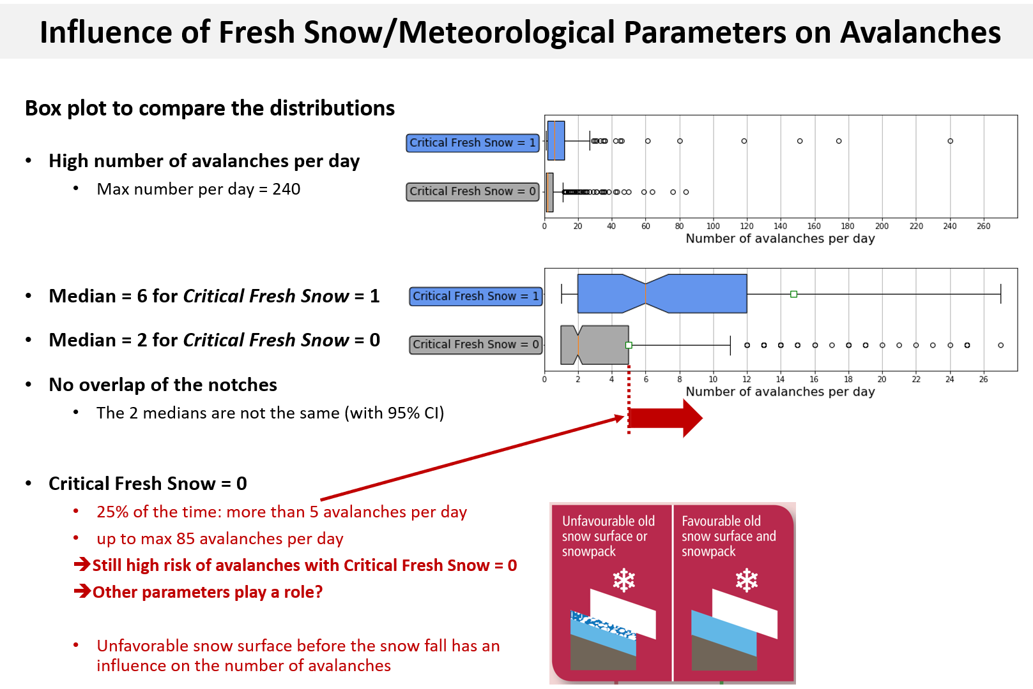

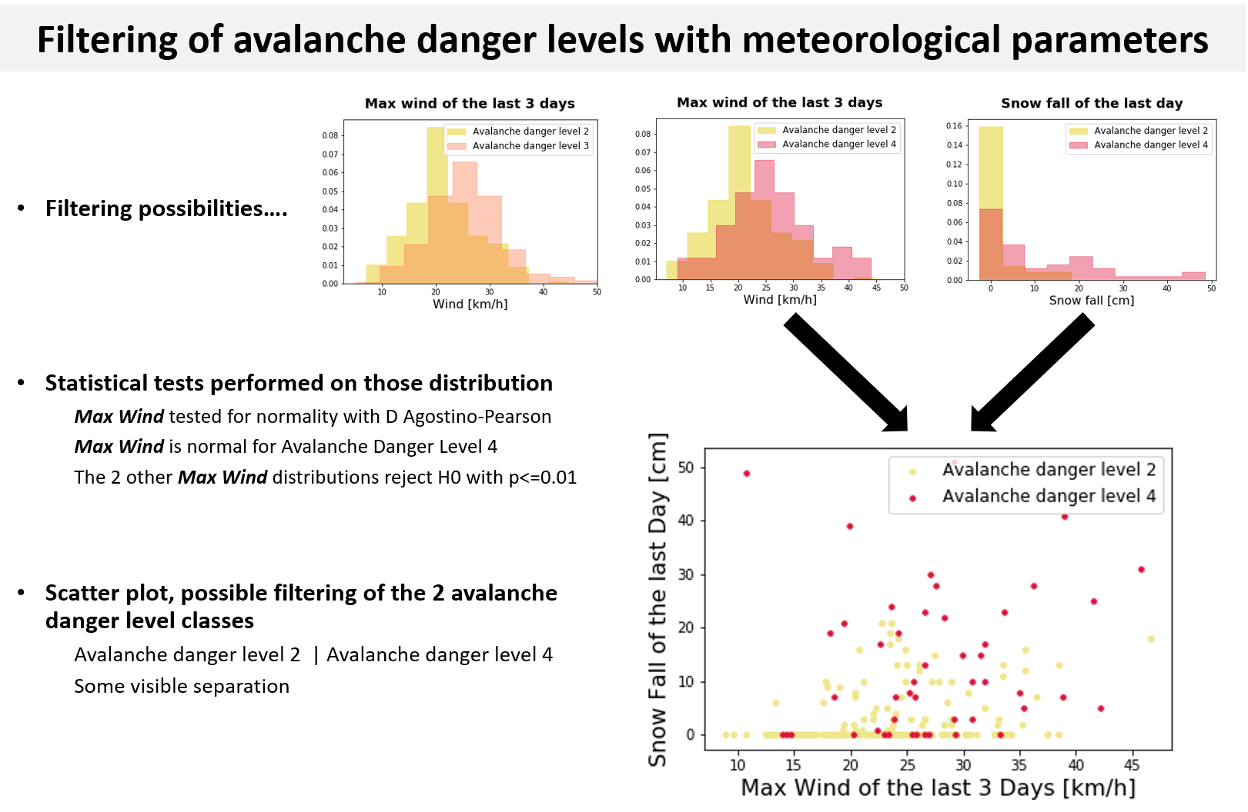

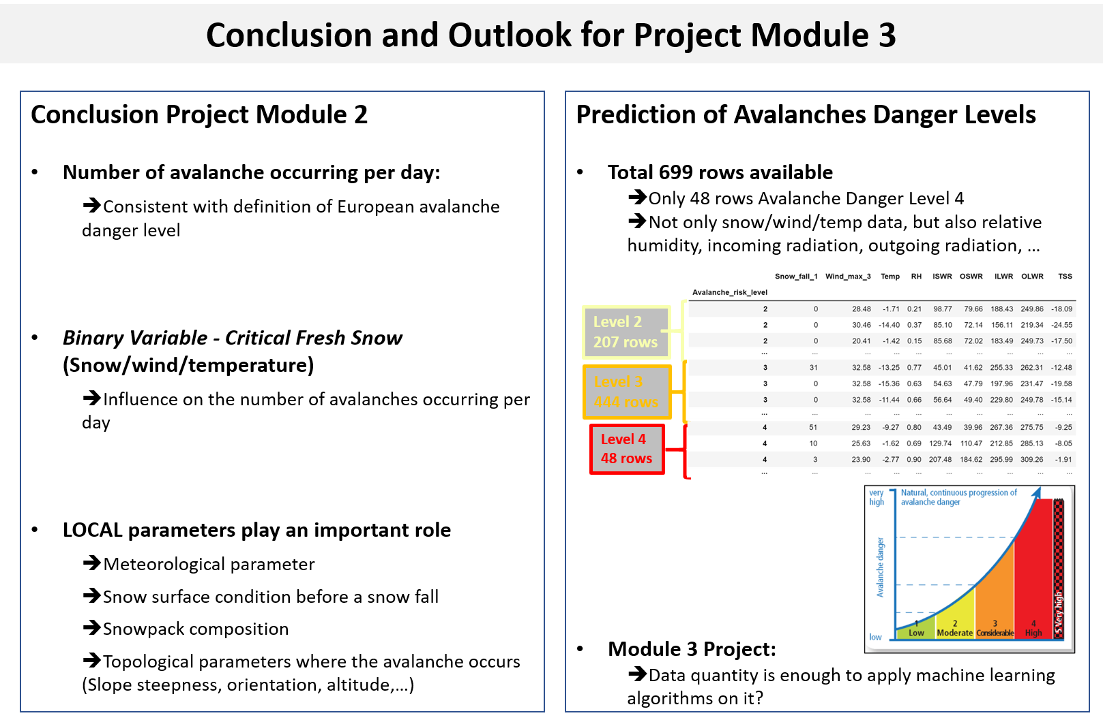

# 10. Conclusion

## Project Module 1

After processing the 2 datasets some basic statistics like avalanches sizes was extracted from the data. From the meteorological Weissfluhjoch data, several parameters were calculated to derive to create the *Critical Fresh Snow* Binary variable to use for some part of the module 2 Project.

Python/Jupyter notebook was used to do that and is a very interesting and user-friendly tool for data collection, processing and pre-analysis.

Some recording mistakes were found in the **Date** parameter of the recorded avalanche by cross-checking with meteorological snow fall (more on how this was done is explained in comments in the Avalanches.ipynb and Meteo.ipynb files), but overall the data quality is good.

## Project Module 2

The Number of avalanches per day increases with the avalanche danger level and this is consistent with the definition of the European avalanche danger level.

The created Binary variable *Critical Fresh Snow* (with wind/temperature parameter) was used to classify the data and it gives an indication on the number of avalanches per day, but other LOCAL parameters like Snow Surface before a snow fall needs to be considered as well

## Outlook Project Module 3

The aim of the Project in Module 3 is to predict Avalanche Danger Levels with Meteorological Parameters. With the combination of the data, 699 rows are available with meteorological parameters:

**Is there enough data to apply machine learning algorithms on this dataset?**

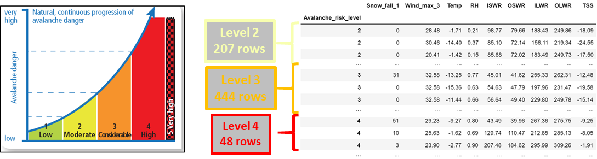

## Broader outlook towards “LOCAL” Avalanche Danger Level Prediction

Currently REGIONAL avalanche prediction is published by the SLF on a daily basis.

No GPS coordinates were recorded in the used Davos avalanche dataset. Having datasets of recorded avalanches with their GPS coordinates would open the possibility to link not only with meteorological parameters, but as well with topological information (steepness of the slope, altitude, orientation,…). As those topological and meteorological LOCAL parameters have a huge influence on the avalanche danger, the availability of such information, would be a first step in order to apply machine learning algorithm for a more LOCAL prediction of the avalanche danger.

Documents, Tools, Data and the WHITE RISK app **[5]** (screen shots in FIGURE 13. below), developed by the Institute for Snow and Avalanche Research, Davos (SLF) is a good first step towards this broader objective and are of great support for the people that want to stay safe in the mountain.

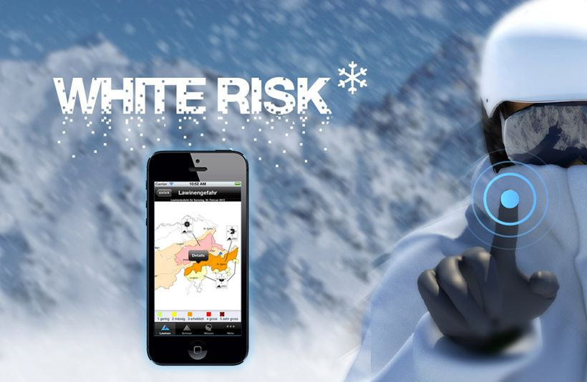

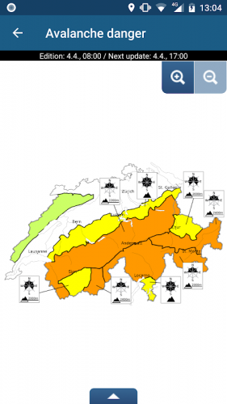 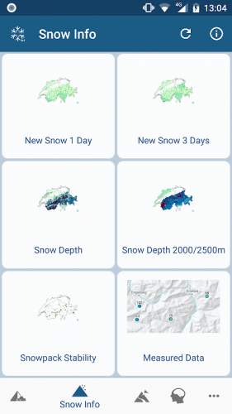 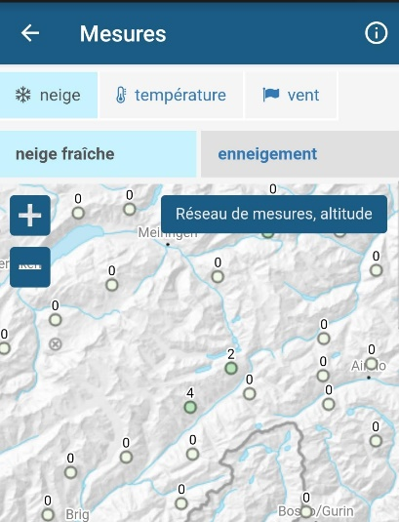

FIGURE 13.: Screen Shots from the White Risk app

# 11. Acknowledgements

I would like to thank the Institute for Snow and Avalanche Research, Davos, as the information available on its website (<https://www.slf.ch/en/index.html>) is very accurate, well presented and interesting. This information as well as the WHITE RISK app, was not only of great help for this project, but also for acquiring knowledge to minimize the risk when going ski touring.

I would like to thank as well Fanny Viret and my classmate Alfonso Garcia Miguel, for helping me in the review of this project.

# 12. References

**[1]** **Leaflet**  **“Caution Avalanches”**

Leaflet published by the SLF, Institute for Snow and Avalanche Research, Davos

<https://www.slf.ch/en/publicationssearch/books-and-brochures.html>

**[2]** **Webpage**  **Avalanche danger scale, European Avalanche Danger Level**

SLF, Institute for Snow and Avalanche Research, Davos

<https://www.slf.ch/en/avalanche-bulletin-and-snow-situation/about-the-avalanche-bulletin/danger-levels.html>

**[3]** **Data Set** ***Snow avalanche data Davos, Switzerland, 1999-2019***

<https://www.envidat.ch/#/metadata/snow-avalanche-data-davos>

Authors: *Jürg Schweizer; Christoph Mitterer; Frank Techel; Andreas Stoffel; Benjamin Reuter*

**[4]** **Data Set** ***WFJ_MOD: Meteorological and snowpack measurements from***

***Weissfluhjoch, Davos, Switzerland***

<https://www.envidat.ch/#/metadata/10-16904-1>

Author: *Nander Weber*

# 13. Table list

*TABLE 1. Avalanche Danger Scale, European Avalanche Danger Levels [2]*

*TABLE 2. Data from the Original Avalanche Dataset*

*TABLE 3. Descriptive Statistic “dry” Avalanche Size*

*TABLE 4. Raw Data from the Meteorological data set*

*TABLE 5. Processed Data from the Meteorological data set (Meteo.csv File)*

# 14. Figure list

*FIGURE 1. Criteria That Defines Critical Fresh Snow Conditions*

*FIGURE 2. Number of avalanches with Human/Natural Causes*

*FIGURE 3. Histogram Avalanche Size*

*FIGURE4. Box Plot Avalanche Size*

*FIGURE 5. Simplified Criteria for the Critical Fresh Snow Variable*

*FIGURE 6. Mean Daily Temperature - Weissfluhjoch Weather Station*

*FIGURE 7. Sum of snow fall of last 3 days - Weissfluhjoch Weather Station*

*FIGURE 8. Mean Daily Wind Speed - Weissfluhjoch Weather Station*

*FIGURE 9. Avalanche Recording Area and Weather Station Location*

*FIGURE 10. Data Flow / Project Concept Overview*

*FIGURE 11. Conceptual Data Model*

*FIGURE 12. Logical Data Model*

*FIGURE 13. Screen Shots from the White Risk app*